AI POWERED COCONUT HARVESTING SYSTEM
Dr. Madhu B.K^{*1}, Syeda Umme Haani^{*2}, S Mohammed Maaz^{*3}, Mahesh S^{*4}, Akshatha G^{*5}
2,3,4,5 Final-year B.E. Students, Department of Computer Science and Engineering, Vidya Vikas Institute of Engineering and Technology, Mysuru, Karnataka, India.
1Dean & Professor, Department of Computer Science and Engineering, Vidya Vikas Institute of Engineering and Technology, Mysuru, Karnataka, India.

ABSTRACT
Manual coconut harvesting depends on climbers working at heights of 15 to 25 metres, and growers have no digital record of which trees are ready to harvest. This paper presents an AI powered coconut harvesting system (Veraxis), a full-stack digital twin platform that turns drone survey imagery into a structured, queryable plantation model and drives a simulated climbing robot to harvest it. A YOLOv8 tree detector processes survey tiles laid out by a configurable flight planner; GPS-proximity matching with a 4 m radius assigns permanent tree identities and mission-scoped observations; a second YOLOv8 model classifies close-up coconuts as Mature, Potential or Premature and writes immutable inventory snapshots; and a nearest-neighbour planner builds immutable harvest missions. The robot is a deterministic, event-driven simulation with a frozen state machine, battery model and WebSocket telemetry, so real hardware would replace only the engine. In our tests the engine reproduced identical traces in 100 of 100 randomised missions with no illegal state transition, nearest-neighbour routes were 5.6 to 9.2 percent longer than optimal for 5 to 8 trees, and re-survey matching created no duplicate trees for position errors up to about 1 m. The robot remains simulated and field trials are future work.
Keywords: Digital Twin, Precision Agriculture, Coconut Harvesting, YOLOv8, Robot Simulation, WebSocket Telemetry
- INTRODUCTION
Coconut is a major plantation crop, yet harvesting it has changed little in decades. The dominant method is a human climber carrying a knife up an unprotected trunk, which is physically dangerous and increasingly hard to staff because fewer young workers are willing to take up the work. A second problem is informational: plantations are usually run from memory or paper, with no canonical list of trees, no position for each, no fruit count per tree and no record of past harvests. The grower therefore cannot easily answer the central economic question of which trees are worth visiting now.
This work addresses both problems with one system, named Veraxis. Its key design decision is to split sensing between two actors with different strengths. A drone gives cheap, wide-area, top-down coverage and is used only to find and locate trees. A climbing robot gives close-up views of the canopy and is used to judge ripeness, which a top-down view from altitude cannot do reliably. Keeping the two tasks in two separate detectors lets each model be retrained or replaced without touching the other.
The contributions of this paper are:
• A two-stage vision pipeline in which a YOLOv8 tree detector on survey tiles feeds a YOLOv8 ripeness classifier on close-up images, with the ripeness model's own class names (Mature, Potential, Premature) used directly as the inventory vocabulary.
• Permanent tree identity through GPS-proximity matching (4 m) combined with a mission-scoped TreeObservation history, so re-surveys never overwrite earlier data or create duplicate trees.
• A digital twin viewer built on a single farm-pixel coordinate system shared by the tile mosaic, the tree overlay and the robot layer.
• A deterministic robot simulation: a pure step(dt) engine, a state machine that is the only component allowed to change robot status, an event bus, append-only telemetry and an observe-only WebSocket stream.
• Immutable harvest missions ordered by nearest-neighbour routing, with backend-computed run analytics, and a reproducible evaluation of the planning, simulation and matching components.
- RELATED WORK
Single-stage detectors in the YOLO family frame detection as one regression problem and run in real time [1], and the Ultralytics YOLOv8 implementation [2] is widely used for agricultural targets. Fruit detection in orchards with deep networks has been studied for crops such as mango and other tree fruit [3], [4]; those systems concentrate on counting and yield estimation from imagery rather than on closing the loop to a harvesting actor. The digital twin idea, a persistent virtual counterpart of a physical asset that is kept in step with it [5], motivates our choice to make the plantation a permanent, queryable object instead of a one-off detection result.
On the planning side, ordering a set of stops to minimise travel is the travelling salesman problem. The nearest-neighbour heuristic is simple and fast but not optimal, and its worst-case behaviour has been analysed [6]; two-exchange (2-opt) local search [7] is a standard way to obtain a stronger reference tour. For control, we model the robot as a finite state machine in the spirit of statecharts [8], and we stream its state to clients with the WebSocket protocol [9] so that live position does not require polling.
- SYSTEM ARCHITECTURE
Veraxis has three layers: a Next.js and React frontend that only presents data, a FastAPI backend that owns all business rules, and PostgreSQL storage accessed through SQLAlchemy. The machine-learning models run locally inside the backend. Fig. 1 shows the end-to-end flow from survey to harvest. The backend is the single source of truth and the frontend never computes business results, which keeps eligibility, planning and state transitions in one place.
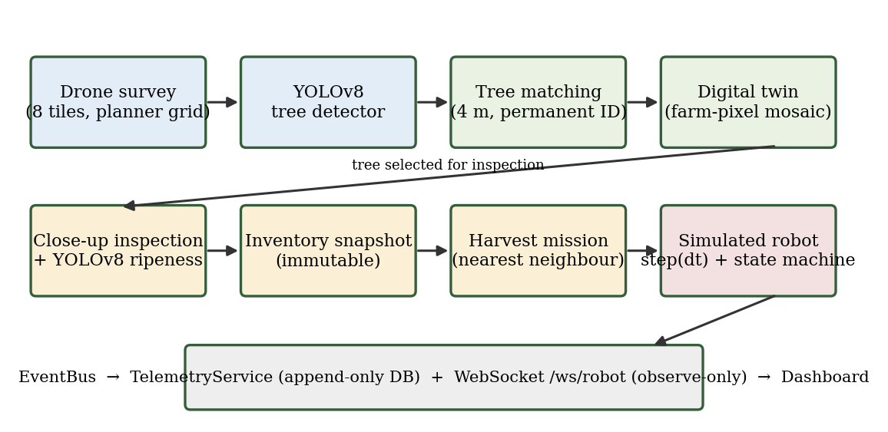
Figure 1: End-to-end pipeline and telemetry path.
The robot subsystem is deliberately split into three concerns. Route planning (which trees, in what order) belongs to the harvest planner. Movement planning (the farm-pixel trajectory between stops) belongs to a pure, stateless navigator. Execution (advancing time, updating position, battery and state) belongs to the simulation engine and its scheduler, the only components that mutate live robot state. Because the contract with the outside world is the HTTP command set plus the WebSocket telemetry frame, a physical robot could replace the simulation engine and leave every other component unchanged.
- METHODOLOGY
A. Survey ingestion and flight planning
A survey mission is created from a folder of drone images. A simulated Flight Planner owns the coverage geometry through an explicit configuration (rows, columns, origin corner, traversal pattern and row/column spacing). The grid is never inferred from the number of images: fewer images than planned positions leave positions empty, and more images than positions raise a validation error (HTTP 422). Positions are visited in boustrophedon (lawnmower) order, and each position stores its grid row and column, capture order and image size on the survey tile. Our demonstration survey uses eight tiles in a 2 x 4 grid.
B. Tree detection
Each tile is passed to a YOLOv8 tree detector with a single class and an inference confidence threshold of 0.4. Detections are stored as raw bounding boxes per tile. They are not trees yet: a detection becomes a tree only after matching.
C. Permanent tree identity
A detection's GPS position is generated from the mission base coordinate, the tile's grid position and the box centre offset, using a ground scale derived from the tile footprint (a spacing of 0.001 degrees, about 111 m, so roughly 0.054 m per pixel for a 2048-pixel tile). Matching uses the Haversine distance: a detection within 4 m of an existing tree reuses it, otherwise a new tree is created with a write-once identifier (TREE-0001, TREE-0002, ...). A hybrid score weights GPS proximity at 0.7 and bounding-box geometry at 0.3 to choose between candidates. Every detection is also stored as a TreeObservation holding the tile, the pixel position, the bounding box and the confidence. Observations are mission-scoped and never overwritten, and each tree points to one representative observation chosen by a fixed rule: highest confidence, then closest to the tile centre, then newest mission.
D. Digital twin and farm-pixel coordinates
The twin lays tiles out by their persisted grid row and column in a continuous mosaic with a small configurable seam gap (Fig. 2). It does not stitch or warp images. A single function computes the farm-pixel position of every tile, and the tree overlay and the robot layer use the same function, so a tree box and the robot marker always agree. GPS remains backend metadata. The viewer uses Pointer Events for pan and pinch zoom, viewport culling and zoom-dependent detail, and selecting a tree opens a read-only details drawer.
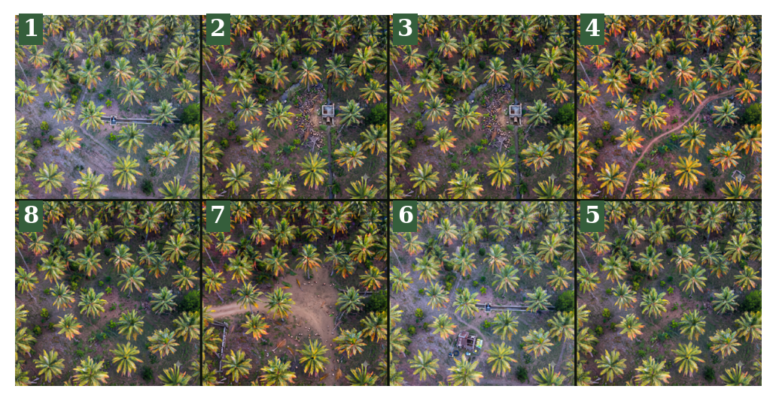
Figure 2: Farm mosaic of the eight demonstration survey tiles in boustrophedon capture order (numbers 1 to 8).
E. Ripeness inspection and inventory
For one tree, close-up images are uploaded as an inspection session and passed to a second YOLOv8 model with three classes (Mature, Potential, Premature) and a confidence threshold of 0.25. Labels are stored in lowercase and aggregated by a direct group-by into an InventorySnapshot with total, mature, potential and premature counts. A snapshot is immutable and unique per inspection. A new scan creates a new snapshot and repoints the tree's current-inventory pointer, so inventory is replaced on every scan, never accumulated, and history is preserved.
F. Harvest planning
The planner reads each tree's latest snapshot and selects trees that are active, have an inventory and contain at least one coconut of the requested type (mature, potential, premature or all). Trees already in a live mission are excluded. Selected trees are ordered by nearest neighbour starting from the depot, with candidates processed in ascending tree-id order and ties resolved by a strict comparison, so the order is reproducible. The result is an immutable harvest mission with one item per tree and a unique constraint that prevents a tree from appearing twice.
G. Robot simulation, state machine and telemetry
The simulation engine advances a context by one fixed step through a pure function, step(dt), with no clock, database or randomness. Movement is linear interpolation between waypoints in farm-pixel space. At each tree the robot climbs (2 s), scans (2 s) and harvests (3 s) in simulated time, then moves on; at the end it returns to the dock. Battery drains only in active states at 1/60 percent per simulated second, which gives about 1 percent per real second at the default 60x speed, and when the level reaches the low threshold (20 percent by default) the engine diverts to the dock.
Robot status is held in eight states (Idle, Moving, Climbing, Scanning, Harvesting, Returning, Error, Docked). A state machine with a frozen transition table is the only component allowed to change the persisted status; every operational state may fault into Error, and Error may recover only to Returning or Idle (Fig. 3). The scheduler drives the engine against wall-clock time at a configurable speed factor and publishes each tick's events to an event bus. A telemetry service appends one telemetry row per tick and one event row per event, and a WebSocket gateway broadcasts the same frames to any number of observe-only clients. When a run ends, one summary record is written with distance, battery use, recharge count, harvest timing and a deterministic mission score equal to 100 x completion x (0.5 + 0.5 x battery economy) x a status factor (1.0 completed, 0.5 aborted, 0.2 failed).
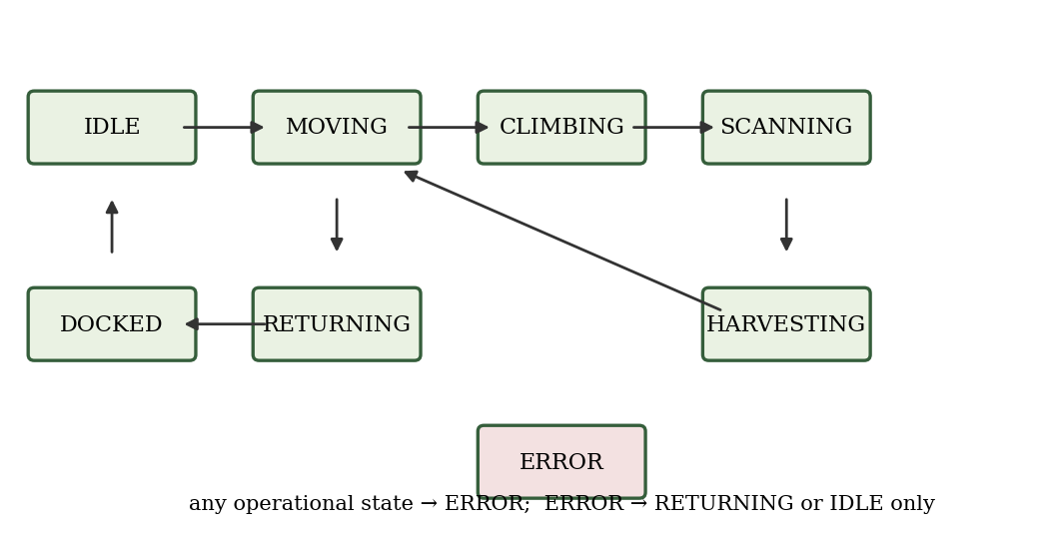
Figure 3: Robot state machine with the frozen legal transitions.
- EXPERIMENTAL SETUP
Two kinds of evidence are reported. First, the two YOLOv8 detectors were trained on public image datasets from Kaggle: a single-class coconut tree dataset for the tree detector and a three-class coconut maturity dataset for the ripeness model, with more than 2000 images in total [confirm exact image counts per dataset]. Training used [epochs, image size, batch size, base weights] with a [train/validation/test split] split, and the trained weights are hosted publicly on Hugging Face (insenix).
Second, the backend logic that does not depend on the weights was evaluated with a reproducible script (experiments.py, fixed random seeds, run against the project's own modules). It covers: E1, determinism of the engine over 100 random missions of 3 to 12 trees, comparing SHA-256 hashes of the full event and state trace across two runs; E2, routing quality of the nearest-neighbour planner against the exact optimum (5 to 8 trees, 100 instances each) and against a 2-opt reference (10 to 100 trees); E3, exhaustive legality of all 64 ordered state pairs; E4, engine invariants and battery diversion; E5, boustrophedon order for 16 grid and origin configurations; E6, tree matching under re-survey position error using the real matching code on a SQLite database; and E7, engine throughput. Tree positions in E1 to E4 and E7 are random on a 4100 x 4100 farm-pixel field with the dock at the origin, and E6 uses 60 synthetic trees at least 8 m apart. These are simulation experiments and not field measurements.
- RESULTS AND DISCUSSION
A. Detector configuration and accuracy
Table 1. Detector configuration used in the platform
Model | Classes | Inference conf. | Dataset
Tree detector | tree (1) | 0.40 | Coconut tree dataset (Kaggle)
Ripeness detector | Mature, Potential, Premature (3) | 0.25 | Coconut maturity dataset (Kaggle)

Table 2. Detection accuracy on the held-out split
Model / class | Precision | Recall | mAP@0.5 | mAP@0.5:0.95
Tree detector | [ ] | [ ] | [ ] | [ ]
Ripeness: all classes | [ ] | [ ] | [ ] | [ ]
Ripeness: Mature | [ ] | [ ] | [ ] | [ ]
Ripeness: Potential | [ ] | [ ] | [ ] | [ ]
Ripeness: Premature | [ ] | [ ] | [ ] | [ ]

Table 2 is to be filled from the validation output of the trained models (results.csv and the confusion matrix) before submission. We do not quote accuracy values that have not been measured.
B. End-to-end functional run
A full workflow was executed on a freshly reset database and recorded during the final audit: eight survey images produced eight tiles and 243 tree detections, which became 243 permanent trees; re-running matching reused the existing trees instead of creating duplicates. One inspected tree yielded 32 detected coconuts (3 Mature, 2 Potential, 27 Premature) and an inventory snapshot. A harvest mission for one eligible tree with three expected coconuts was started, the simulated robot navigated, harvested three coconuts and returned to the dock, the mission completed, and a run record with timeline, per-tree activity and log was produced. Over the WebSocket, two simultaneous clients received frames, the number of telemetry rows matched the number of frames for the run, and a disconnecting client did not stop the run.
C. Determinism and state-machine correctness
Table 3. Simulation engine and state machine checks
Check | Result
E1: identical event and state trace over two runs (random missions) | 100 / 100
E3: legal / illegal ordered state pairs | 17 / 47 of 64
E3: self-transitions allowed | 0
E3: operational states that can fault to Error | 7 of 7
E4: illegal transitions attempted by the engine | 0 in 100 missions
E4: missions ending finished and Docked | 100 / 100
E4: missions with non-increasing battery | 100 / 100
E4: missions harvesting every tree (others diverted by low battery) | 88 / 100
E4: mean state transitions per tree | 4.4
Battery drain at default 60x speed | 1.0 % per real second

The engine produced byte-identical traces in every trial, which is what allows runs to be replayed and regression-tested without a clock. The engine never requested an illegal transition because every request passed through the transition table. In the stress test at the lowest speed (1 farm-pixel per simulated second) with 10 to 40 trees, the low-battery rule triggered in all four cases and the robot ended Docked, but with the battery at 0.0 percent each time (Table 4 shows the harvested counts). The fixed 20 percent threshold therefore does not guarantee arrival with reserve when the dock is far away, and a distance-aware return threshold is an obvious improvement.
Table 4. Battery-low diversion stress test (speed 1.0 px per simulated second)
Trees | Plan length (px) | Harvested | Final state | Final battery (%)
10 | 29935 | 2 | DOCKED | 0.0
20 | 36815 | 2 | DOCKED | 0.0
30 | 72290 | 1 | DOCKED | 0.0
40 | 90398 | 1 | DOCKED | 0.0

D. Routing quality
Table 5. Nearest-neighbour tour length (round trip from the dock)
Trees | Reference | NN excess mean (%) | NN excess max (%) | Random order
5 | exact optimum | 5.56 | 20.89 | 1.33x
6 | exact optimum | 5.92 | 28.79 | 1.47x
7 | exact optimum | 8.63 | 30.31 | 1.55x
8 | exact optimum | 9.24 | 28.02 | 1.66x
10 | 2-opt reference | 10.14 | - | 1.72x (vs NN)
20 | 2-opt reference | 14.42 | - | 2.28x (vs NN)
50 | 2-opt reference | 15.0 | - | 3.83x (vs NN)
100 | 2-opt reference | 16.69 | - | 5.33x (vs NN)

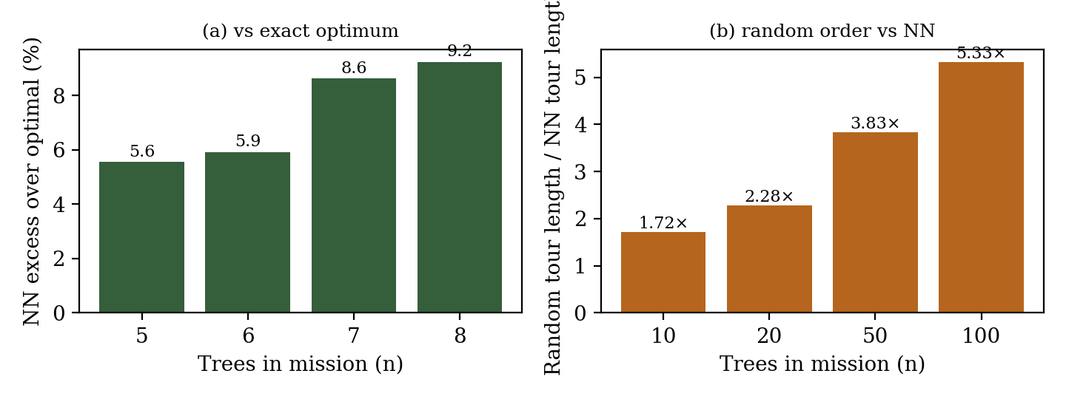
Figure 4: (a) Nearest-neighbour excess over the exact optimum; (b) random-order tour length relative to nearest neighbour.
Nearest neighbour was on average 5.6 to 9.2 percent longer than the exact optimum for 5 to 8 trees, with a worst case of 30.3 percent, and its excess over a 2-opt reference grew from 10.1 percent at 10 trees to 16.7 percent at 100 trees. A random visiting order was 1.7 to 5.3 times longer than nearest neighbour as missions grew. Nearest neighbour is therefore a sound first choice: it is explainable, deterministic and far better than an unordered visit, but a 2-opt pass would remove a further 10 to 17 percent of travel and is a low-cost extension.
E. Tree matching under re-survey error
Table 6. Re-survey matching with 60 trees spaced at least 8 m apart
Error (px) | Error (m, per axis) | Trees after survey 1 | Trees after re-survey | Duplicates
0 | 0.0 | 60 | 60 | 0
10 | 0.54 | 60 | 60 | 0
20 | 1.09 | 60 | 60 | 0
40 | 2.17 | 60 | 71 | 11
80 | 4.34 | 60 | 79 | 19

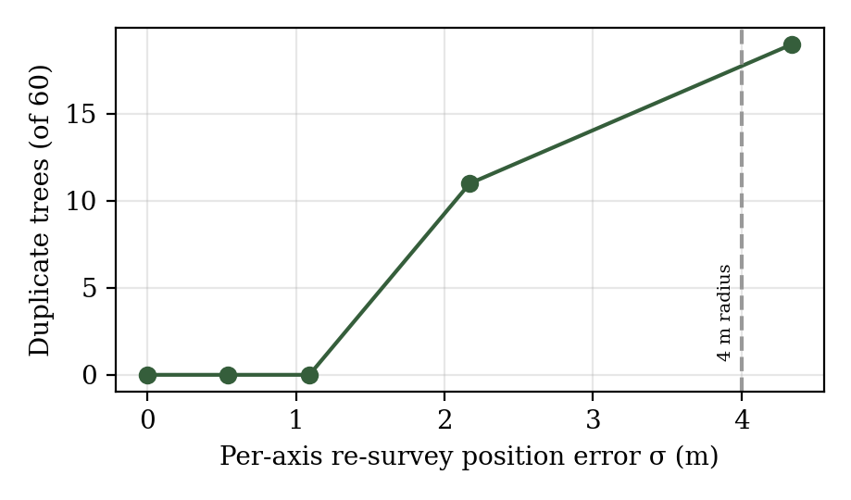
Figure 5: Duplicate trees created on re-survey as position error grows.
Survey 1 produced exactly the 60 true trees (no false merges), and a re-survey with per-axis error up to about 1.1 m created no duplicates. At 2.2 m and 4.3 m the rule created 11 and 19 duplicates, which matches what a fixed 4 m radius implies for a two-dimensional Gaussian error. The result also exposes the rule's main assumption: trees closer than 4 m are merged. In a preliminary run with trees placed freely at random, 14 of 60 trees were merged for that reason. Coconut palms are normally planted at wider spacing, typically around 7.5 to 9 m [add a citation], so the 4 m radius is safe for plantations but should be reduced for very dense plots.
F. Throughput and engineering observations
In our test environment the engine ran at about 114,575 to 119,599 one-second steps per second on a single CPU core, more than 800 times the 60 steps per second needed to run in real time at the default 60x speed, so simulation cost is negligible next to database round-trips. The latter dominated the deployed system: the managed serverless PostgreSQL adds a round-trip floor of roughly 2 s per request, a batched update of 302 rows took about 80 s, and replacing a per-tree query loop (about 600 sequential queries) with two grouped aggregates reduced the tree-summary endpoint from a hang beyond 20 s to about 3 s. These observations are from the development log of the project and were not measured under a controlled benchmark.
- LIMITATIONS AND FUTURE WORK
The robot is simulated and no physical climbing hardware has been integrated, so mechanical grasping, trunk climbing and sensing noise are not evaluated. GPS positions are generated from a base coordinate and the tile grid rather than read from real geotags, which means absolute positions are synthetic although relative geometry is consistent. The system supports one farm and one robot, has no authentication, and renders tree overlays with DOM elements, which performs well at about 300 trees but will need canvas rendering or stronger culling for thousands. The detectors were evaluated on a held-out split of public datasets and have not been field-tested on our own plantation imagery. The routing experiments use random positions rather than surveyed plantations.
Future work includes field validation of both detectors on locally captured images, real geotagging and RTK positions, a distance-aware battery return rule, 2-opt route refinement, post-harvest verification scans, multi-robot and multi-farm support, and replacing the simulation engine with a physical robot that satisfies the same telemetry and command contract.
- CONCLUSION
Veraxis shows that a plantation can be treated as a persistent digital asset: drone tiles become permanent, deduplicated trees; close-up scans become immutable inventory; and a planner turns inventory into a reproducible harvest mission executed by a robot whose behaviour is fully backend-owned. Separating the tree detector from the ripeness detector keeps each model independently replaceable, and separating route planning, movement planning and execution keeps the robot layer replaceable by real hardware. The simulation experiments confirm that the engine is deterministic, that the state machine is respected, that nearest-neighbour routing is acceptable but improvable, and that the matching rule is robust to sub-metre re-survey error. The main remaining work is hardware integration and field validation of the detectors.
ACKNOWLEDGEMENTS
The authors thank their project guide Dr. Madhu B.K, the Department of Computer Science and Engineering and the management of Vidya Vikas Institute of Engineering and Technology Mysuru for their guidance and support.
- REFERENCES
- J. Redmon, S. Divvala, R. Girshick and A. Farhadi, “You Only Look Once: Unified, Real-Time Object Detection,” Proc. IEEE Conf. on Computer Vision and Pattern Recognition (CVPR), 2016, pp. 779-788.
- G. Jocher, A. Chaurasia and J. Qiu, “Ultralytics YOLOv8,” 2023. [Online]. Available: https://github.com/ultralytics/ultralytics
- A. Koirala, K. B. Walsh, Z. Wang and C. McCarthy, “Deep learning for real-time fruit detection and orchard fruit load estimation: benchmarking of MangoYOLO,” Precision Agriculture, vol. 20, pp. 1107-1135, 2019.
- S. Bargoti and J. Underwood, “Deep fruit detection in orchards,” Proc. IEEE Int. Conf. on Robotics and Automation (ICRA), 2017, pp. 3626-3633.
- M. Grieves and J. Vickers, “Digital Twin: Mitigating Unpredictable, Undesirable Emergent Behavior in Complex Systems,” in Transdisciplinary Perspectives on Complex Systems, Springer, 2017, pp. 85-113.
- D. J. Rosenkrantz, R. E. Stearns and P. M. Lewis II, “An analysis of several heuristics for the traveling salesman problem,” SIAM Journal on Computing, vol. 6, no. 3, pp. 563-581, 1977.
- G. A. Croes, “A method for solving traveling-salesman problems,” Operations Research, vol. 6, no. 6, pp. 791-812, 1958.
- D. Harel, “Statecharts: A visual formalism for complex systems,” Science of Computer Programming, vol. 8, no. 3, pp. 231-274, 1987.
- I. Fette and A. Melnikov, “The WebSocket Protocol,” RFC 6455, Internet Engineering Task Force, 2011.

